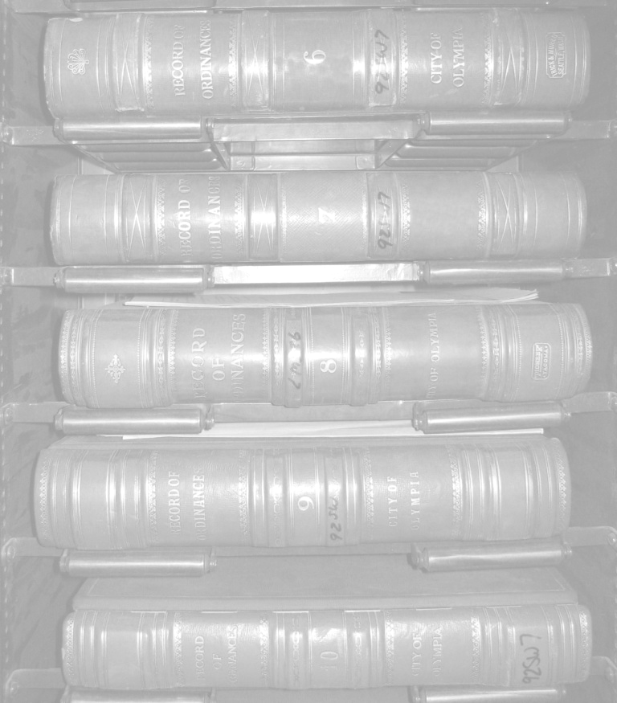
2011-2013
LOCAL RECORDS GRANT PROGRAM
GUIDEBOOK & APPLICATION
* * * * * * * * * *
Efficiency
Preservation
Access
WASHINGTON STATE ARCHIVES
Documenting Democracy
APPLICATION DEADLINE: May 20, 2011
For more information: http://www.sos.wa.gov/archives/lrgp2011-13.aspx

Jerry Handfield Patrick Williams
State Archivist Local Records Grant Coordinator
Jerry.handfield@sos.wa.gov patrick.williams@sos.wa.gov
360-586-2664 360-586-0108

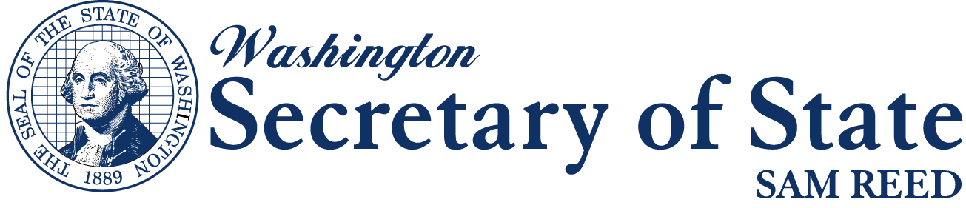

Washington State Archives - Digital Archives

Cheney, Washington

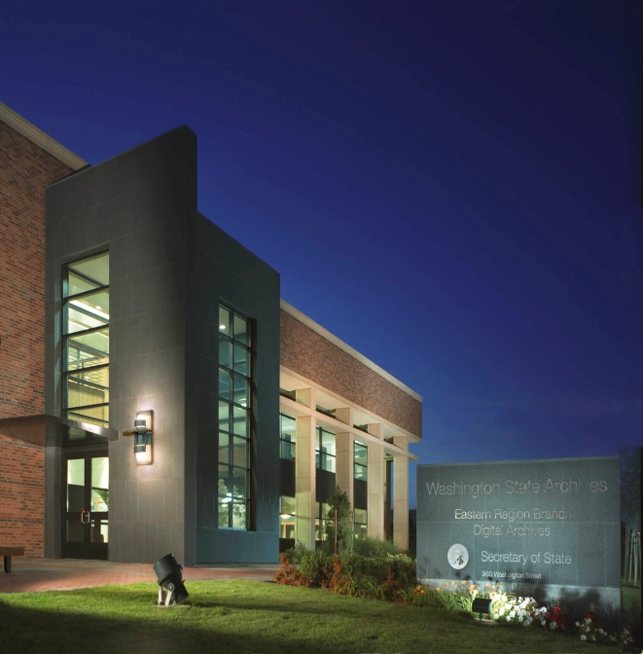

www.digitalarchives.wa.gov

TABLE OF CONTENTS
1. INTRODUCTION 3
1.1 Purpose 3
1.2 Focus for 2011-13 Grant Program 3
1.3 Timetable 3
1.4 Eligible Applicants 3
1.5 Approved Grant Project Categories 4
1.6 Application Review and Award Process 4
1.7 Other Funding Sources 4
2. GRANT INFORMATION 4
2.1 What can I expect from this grant? 4
2.2 Staff Assistance 5
2.3 Grant Payments 5
2.4 Reports 5
2.5 Project Changes 5
3. APPLICATION PREPARATION TIPS 5
3.1 Step One – Getting Oriented 5
3.2 Step Two – Getting Started 5
3.3 Step Three – Putting It All Together 6
4. APPLICATION INSTRUCTIONS 6
4.1 Application Section 1 6
4.2 Application Section 2 7
4.3 Record Inventory Forms 7
5. ADMINISTRATIVE RULES 8
5.1 WAC 434-670 8
Local Records Grant 2011-13 Application A1

2011-2013 GUIDEBOOK
The Washington State Archives Local Records Grant Program, administered by the Office of the Secretary of State, provides financial assistance to local government officials to support records management and preservation efforts, particularly for records with permanent retention. This grants-in-aid program is a significant effort in the Archives’ overall mission to enhance the quality of archival preservation and public access to records of enduring value. (Chapter 434-670-010 WAC)

This Guidebook is designed for local government agencies, that wish to apply for a Local Records Grant, and it contains information and the necessary application forms.

Applicants must consult with Regional Branch Archives staff to ensure a properly completed application.

Call or e-mail the Archives for your region to discuss what you would like to accomplish with a Local Records Grant, and to get help developing your project proposal.

Northwest Counties:
Megan Bezzo 360-485-5822 megan.bezzo@sos.wa.gov

Clallam, Island, Jefferson, San Juan, Skagit, Snohomish, Whatcom Counties

Southwest Counties:
Leslie Koziara 360-586-4893 leslie.koziara@sos.wa.gov

Clark, Cowlitz, Grays Harbor, Lewis, Mason, Pacific, Skamania, Thurston, Wahkiakum Counties

Central/Eastern Counties:
Scott Sackett 509-413-3296 scott.sackett@sos.wa.gov

Adams, Asotin, Benton, Chelan, Columbia, Douglas, Ferry, Franklin, Garfield, Grant, Kittitas, Klickitat, Lincoln, Okanogan, Pend Oreille, Spokane, Stevens, Walla Walla, Whitman, Yakima Counties

Puget Sound Counties:
Mike Saunders 425-564-3950 mike.saunders@sos.wa.gov

King, Kitsap, Pierce Counties

Questions regarding the Grant Program, your project, or your application may also be directed to:

Local Records Grant Coordinator:
Patrick Williams 360-586-0108 patrick.williams@sos.wa.gov

Applications MUST BE POSTMARKED no later than May 20, 2011
Local Records Grant Program
Washington State Archives
PO BOX 40238
Olympia, 98504-0238

1. INTRODUCTION

1.1 Purpose

Since 2002, the Washington State Archives’ Local Government Records Grant Program has supported local public records management and preservation efforts. Digitization and preservation of these critical public records are a part of a sound Records Management plan. The Grants are funded with fees collected by County Auditors and Clerks. This is a competitive grant program and the number of grant applications and the requested level of grant funding generally exceeds the total award amount available each grant cycle. Grant applications are reviewed by Washington State Archives staff and forwarded to the State Archives Oversight Committee. The Committee then reviews and makes funding recommendations to the Secretary of State. Local government agencies representing populations of all sizes are encouraged to apply.

1.2 Focus for 2011-13 Grant Program

The 2011-2013 Local Records Grant cycle focuses on the digitization and microfilming of archival records to facilitate public access and ensure long-term preservation. Digital records will be indexed and hosted by the Washington State Digital Archives, while security microfilm of the records will be stored in climate controlled vaults at the State Archives building in Olympia.

Grand awards of up to $10,000 are available to digitize and microfilm the following record series:
- Minutes (DAN GS50-05A-13)
- Ordinances (DAN GS50-05A-16)
- Resolutions (DAN GS50-05A-16)
Agencies are strongly encouraged to transfer the original records to the appropriate Regional Branch of the Washington State Archives once their grant project is completed. This will further ensure permanent preservation of the records, and will also reduce storage costs for the agency. The State Archives staff are happy to answer any questions relating to your records, and the grant process.

1.3 Timetable

The grant project will begin on the date of the award letter from the Secretary of State and will run through May 31, 2013. All work on the grant project must be completed and invoiced by May 15th, 2013.

April 15, 2011 Grant application available
May 20, 2011 Grant application postmark deadline
June 27, 2011 Archives Oversight Committee makes award recommendations
July 2011 Secretary of State makes final award decisions
July 2011 Awards announced
August 2011 Award Ceremonies with Sam Reed
August 2011 Contracts sent out to recipients
May 15, 2013 All work on grant projects must be complete and invoiced
May 31, 2013 Final narrative report due

1.4 Eligible Applicants

Any local government or political subdivision with taxing authority may apply for Local Records Grant funds. This includes (but is not limited to) cities and towns, school districts, conservation districts, law enforcement agencies, and port districts. State and federal agencies are not eligible for this program. Agencies representing populations of all sizes are encouraged to apply for the Grant.

1.5 Approved Grant Project Categories

Approved project budget categories eligible for grant funding include:
- Imaging Services, such as microfilming, scanning, and duplicating microfilm. State Archives’ Imaging Services (IS) is the default vendor for all imaging projects (scanning, microfilming/duplication). In the event that (IS) is unable to undertake or complete a project, grant recipients will work with the archives to secure an appropriate vendor.
- Other approved services and commodities that are pertinent and necessary to the project, including archival storage boxes and transport of the records.

1.6 Application Review and Award Process

The grant review process is a competitive one, with a set amount of grant monies available for distribution. Archives regional contacts and the Local Records Grant Coordinator are available to provide assistance and guidance in completing the application prior to the application deadline.

Applications are reviewed for eligibility, completeness, and conformity to application requirements. The Washington State Archives Oversight Committee (AOC) considers the importance and historical value of the records, and will give additional consideration toward projects where the applicant agency plans to transfer the original documents to the Regional Archives, along with related meeting agenda packets or master indexes, at the completion of the project. The AOC evaluates applications and determines award recommendations (full, partial, or denial of funding). The proposed award list is then forwarded to the Secretary of State for approval. All applicants are notified by mail.

1.7 Other Funding Sources
The State Archives also encourages local agencies to pursue other available funding sources for preservation of historical records such as the following:
RCW 36.22.170 (1)(a) Except as provided in (b) of this subsection, a surcharge of five dollars per instrument shall be charged by the county auditor for each document recorded, which will be in addition to any other charge authorized by law. One dollar of the surcharge shall be deposited in the county general fund to be used at the discretion of the county commissioners to promote historical preservation or historical programs, which may include preservation of historic documents.

2. GRANT INFORMATION

2.1 What can I expect from this grant?

- Your records will be collected by Imaging Services where they will be digitized and indexed according to previously formatted standards. Each record will be indexed and imaged as a separate document.
- Digital versions of the originals will be hosted by the Washington State Archives Digital Archives. A link to the records can be attached to your agency webpage to facilitate public access.
- Security Microfilm, in accordance with state standards, will be created by Imaging Services and transferred to vaulted storage at the State Archives Building in Olympia. Detailed Inspection results will be sent to the grantee.
- If requested, a working copy of all records can be supplied either digitally or in microfilm.

2.2 Staff Assistance

Retain this Guidebook for your reference and use after award of grant funds. Many questions that will arise as you implement your project are covered in this publication. Additional pertinent information, materials and forms will be sent to the project contact after grants are awarded.

Washington State Archives staff is available to guide and assist you in applying for grant funds and in successfully completing your project. Contact information is on the first and last pages of this Guidebook.

2.3 Grant Payments

No funds will be disbursed to the Grantee. The payment of credit for services is as described:
- An invoice will be created by the Archives’ Financial Services upon delivery of archival storage boxes.
- The invoice will be paid by the Archives through a transfer of funds upon delivery of archival storage boxes.
- An invoice will be created by the Archives Imaging Services upon delivery of the completed project.
- The invoice will be paid by the Archives through a transfer of funds upon approval by the Grantee of services provided.
- The Archives will send a copy of the paid invoices for reference to the Grantee.

Costs incurred prior to the effective date of the Grant Agreement shall be disallowed under the Grant. Should the Grantee incur costs prior to the effective date of the Grant Agreement, it does so at its own risk.

2.4 Reports

The Local Records Grant Program rules stipulate that a final report with both narrative and financial components be completed and submitted at the end of the project period, but no later than May 31, 2013. Online forms will be available at www.sos.wa.gov/archives/lrgp2011-13 . Copies of invoices for grant project expenditures must be attached to the final report.

2.5 Project Changes

The State Archivist of Washington must receive a written request prior to any revisions to a project’s budget. The written request must include the reason for the revision, the total dollar amount of funds to be reallocated, and identification of which budget categories and/or budget line items are to be reduced or increased, and by what amount. Program change requests, such as added or deleted record series, also require a prior written request.

3. APPLICATION PREPARATION TIPS

3.1 Step One – Getting Oriented

- READ this Guidebook and Application to become familiar with the program.
- Determine if your agency, institution or organization is eligible for this grant program.
- Understand what your responsibilities will be if you are awarded a grant.

3.2 Step Two – Getting Started

- Call or e-mail the Archives contact for your Region to discuss what you would like to accomplish with a Local Records Grant. This required step will help your agency to develop a strong and well-designed application.

- KEEP this Guidebook! You will want to refer to specific sections as you develop your proposal, and it will be a ready source of information to effectively administer an awarded grant.
- Allow sufficient time to complete the application; do not procrastinate.
- Prepare a draft and ask your Archives contact to review it.

3.3 Step Three – Putting It All Together

- Fill out the application in digital format and print it out the original for the necessary signatures and dates.
- Be sure to respond to all questions and sections to complete the application.
- Have someone review your draft for clarity, typos and spelling errors.
- Make sure you have the two required signatures of agency officials.
- Submit only the required form; your proposal will be judged on content, not weight.

4. APPLICATION INSTRUCTIONS

The instructions define each section of the application. Submit your original signed application, stapled in the upper left-hand corner. Do not use tabs, dividers, binders or folders. Applications MUST be postmarked no later than May 20, 2011. No faxed or E-mailed applications will be accepted. Please use the following address:

Local Records Grant Program
Washington State Archives
PO BOX 40238
Olympia, WA 98504-0238

4.1 Application Section 1

Applicant Agency
- This refers to the local government entity (or a sub-unit thereof) with taxing authority as defined by Washington State Statute. This agency is generally the direct beneficiary of the applied grant funds.
Primary Project Contact
- This is the individual responsible for implementing the project on a day-to-day basis. State Archives contact will be with this individual during the grant project.
Authorizing Official
- The signatory individual must be the authorized local governmental or political subdivision official with the statutory authority to enter into binding contracts and encumber funds for the applicant agency. This official will also be the signatory agent for the Grant Agreement, which establishes a contractual relationship between Secretary of State, Washington State Archives and the awarded grantee.
Authorizing Agency
- This is the local government entity or political subdivision with the authority to enter into binding contracts and encumber funds.
Application Prepared by
- This entry identifies the individual responsible for gathering the application information and completing the forms. State Archives will contact this person should specific information pertaining to the proposed project be required.
Legislative District
- This information is used for statistical purposes and to notify elected officials when grants are awarded. If you are unsure of your district, please contact your local election authority.
Federal Employer Identification Number (FEIN)
- This number is necessary to set up your grant payment account.
Signature of official
- Signature of the Authorizing Official establishes official approval of the submitted project proposal and budget. Be sure to include a date.

4.2 Application Section 2

Which records are you requesting to be digitized?
- Select one or more of the record series that you wish to have included in your project. Include the year range for each series.
Have you previously digitized or microfilmed any portion of these records?
- This will help Archives staff to locate any existing copies.
Are there any gaps in the date ranges specified above?
- This will help you and Archives Staff to search for any missing records.
Will you be transferring your records and associated files to the Washington State Archives?
- Additional consideration will be given to those applicants that are willing to transfer the originals and associated files to the Washington State Archives.
Have you discussed this grant application with your Archives contact?
- This check-box serves as confirmation that your agency has completed this required step.
How many archival boxes will you be requesting?
- Each acid free box holds 1 cubic foot of records. Each box holds approximately 2,500 pages.

4.3 Record Inventory Forms
The information provided will be used to estimate the cost of your project. Here are some descriptions that may help with the inventory of your records.
- To inventory your paper records for digitization, they should be divided into two categories:

PERMANENT - BOUND
POST BOUND/LOOSE PAPER

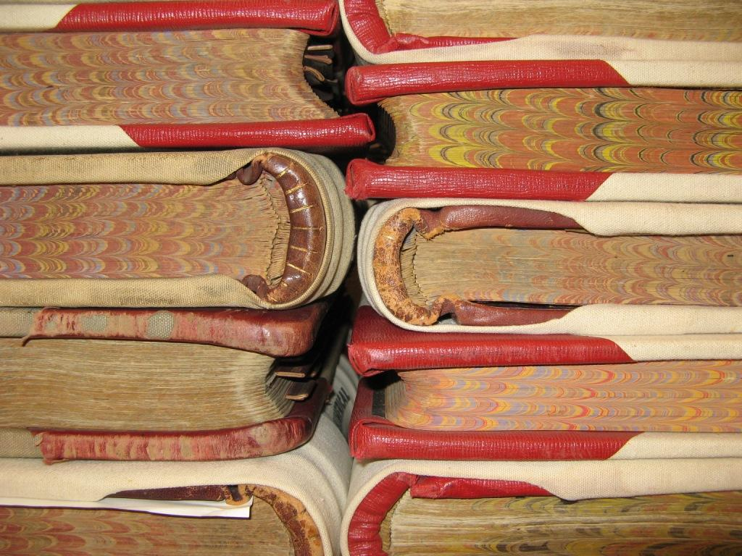
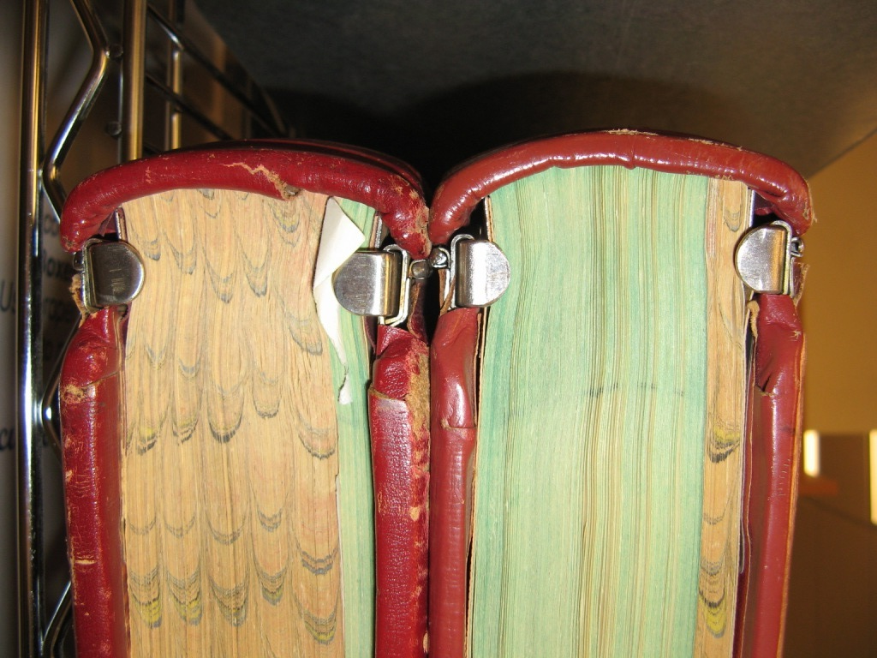

- Permanent-bound material cannot be fed through a digital scanner and must be handled in a separate process. Post-bound and loose paper can be disassembled, fed through a scanner, and then re-assembled (unless damaged or fragile).
- Previously microfilmed records can be digitized using a film-scanner, while microfiche are more commonly used as a working copy of a microfilm original, and do not readily transfer to digital format.

MICROFILM
MICROFICHE



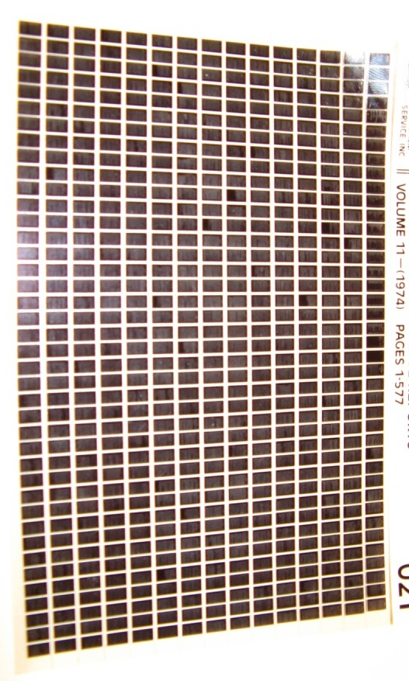

- Date Range What years do your records encompass?
- Number of Pages This will help the Archives estimate of the breadth of your project .
- Number of boxes/volumes Part of the transportation cost is related to the number of boxes.
- Size This will help the Archives determine how best to scan the records.
- Single-sided vs. double-sided What format is the majority of your project?
- More than one record per page This will help the Archives estimate scanning and indexing time.
- Condition of records What is the physical condition of the majority of your project?

5. ADMINISTRATIVE RULES

5.1 WAC 434-670
The Washington State Archives Local Records Grant Program Administrative Rules can be located online at http://apps.leg.wa.gov/WAC/default.aspx?cite=434-670

Local Records Grant 2011-13 Application
Section 1
Applicant Agency

Agency Head (First, Last) |  | Position Title/Division | Phone Number
Name of Primary Project Contact (First, Last) |  | Position Title/Division | Phone Number
E-mail –Primary Project Contact |  | Fax Number | Legislative District
Applicant Agency Address (Street, City, State, Zip Code) |  | Mailing Address - if different (Street, City, State, Zip Code)
Authorizing Agency Official (First, Last) |  | Authorizing Official Position Title/Division
Name of individual to whom the check should be mailed: |  | Address of individual to whom the check should be mailed:
E-mail Address |  | Fax number | Phone Number
Application Prepared by (First, Last) |  | Position Title/Division | Phone Number
Notes or Additional Information:

Federal Employer Identification Number (FEIN):

Signature Showing Certification of Authority to Secure and Encumber Project Funds
Signature of Agency Head | Date | Signature of Authorizing Official |  | Date
To be Completed by Washington State Archives Staff Only
Application Complete & Accepted |  | Grant Awarded or Denied Date
Name Date |  | Notification Mailed Date

Local Records Grant 2011-13 Application
Section 2
This information will be used to help Archives Staff prioritize the preservation of your records
- Which eligible record series are you requesting to be digitized?

Minutes
DAN (GS50-05A-13) Year through Year

Ordinances
DAN (GS50-05A-16) Year through Year

Resolutions
DAN (GS50-05A-16) Year through Year

- Have you previously digitized or microfilmed any portion of these records?

Yes Year through Year

No

- Are there any gaps in the date ranges specified above?

Yes Year through Year

No

- Will you be transferring your original records to the Washington State Archives?

Yes No

5. Will you also be transferring associated indexes and/or Agenda Packets with the series?
Yes No

6. Have you discussed this grant application with your Regional Archives Contact?
Yes No

7. How many archival boxes will you be requesting?

MINUTES RECORD INVENTORY FORM
Please be as accurate as possible. This information will be used to estimate the cost of your project.

What is the Governing Body for this Minute series? i.e. City Council
What format(s) are your records stored in? See choices below
Permanently Bound
- Date Range to
- Estimated total number of pages
(2500 pages per cubic foot)
- Total number of volumes
- Size
Letter Legal Over 11 x 17

- Single-Sided Double-Sided Combination
- More than one Minute per page? Yes No
- What is the condition of the records? Poor Good

Post Bound or Loose
- Date Range to
- Estimated total number of pages
(2500 pages per cubic foot)
- Total number of boxes/volumes /
- Size
Letter Legal Over 11 x 17

- Single-Sided Double-Sided Combination
- More than one Minute per page? Yes No
- What is the condition of the records? Poor Good

Microfilm
- Date Range to
- Estimated total number of images
(16mm reels hold about 2000 images per reel)
(35mm reels hold about 500 images per reel)
- What type of microfilm are these reels?
Acetate Diazo Silver
- Size
16mm 35mm 16/35mm
- More than one Minute per frame? Yes No
- What is the condition of the records? Poor Good

Your digital project will be hosted by the Washington State Digital Archives at no additional charge. Do you need a Copy of these records for your office?
Microfilm External Hard Drive

ORDINANCES RECORD INVENTORY FORM
Please be as accurate as possible. This information will be used to estimate the cost of your project.

What is the Governing Body for this Ordinance series? i.e. City Council
What format(s) are your records stored in? See choices below
Permanently Bound
- Date Range to
- Estimated total number of pages
(2500 pages per cubic foot)
- Total number of volumes
- Size
Letter Legal Over 11 x 17

- Single-Sided Double-Sided Combination
- More than one Ordinance per page? Yes No
- What is the condition of the records? Poor Good

Post-Bound or Loose
- Date Range to
- Estimated total number of pages
(2500 pages per cubic foot)
- Total number of boxes/volumes /
- Size
Letter Legal Over 11 x 17

- Single-Sided Double-Sided Combination
- More than one Ordinance per page? Yes No
- What is the condition of the records? Poor Good

Microfilm
- Date Range to
- Estimated total number of images
(16mm reels hold about 2000 images per reel)
(35mm reels hold about 500 images per reel)
- What type of microfilm are these reels?
Acetate Diazo Silver
- Size
16mm 35mm 16/35mm
- More than one Ordinance per frame? Yes No
- What is the condition of the records? Poor Good

Your digital project will be hosted by the Washington State Digital Archives at no additional charge. Do you need a copy of these records for your office?
Microfilm External Hard Drive

RESOLUTIONS RECORD INVENTORY FORM
Please be as accurate as possible. This information will be used to estimate the cost of your project.

- What is the Governing Body for this Resolution series? i.e. City Council
- What format(s) are your records stored in? See choices below
Permanently Bound
- Date Range to
- Estimated total number of pages
(2500 pages per cubic foot)
- Total number of volumes
- Size
Letter Legal Over 11 x 17

- Single-Sided Double-Sided Combination
- More than one Resolution per page Yes No
- What is the condition of the records? Poor Good

Post Bound or Loose
- Date Range to
- Estimated total number of pages
(2500 pages per cubic foot)
- Total number of boxes/volumes /
- Size
Letter Legal Over 11 x 17

- Single-Sided Double-Sided Combination
- More than one Resolution per page Yes No
- What is the condition of the records? Poor Good

Microfilm
- Date Range to
- Estimated total number of images
(16mm reels hold about 2000 images per reel)
(35mm reels hold about 500 images per reel)
- What type of microfilm are these reels?
Acetate Diazo Silver
- Size
16mm 35mm 16/35mm
- More than one Resolution per frame? Yes No
- What is the condition of the records? Poor Good

Your digital project will be hosted by the Washington State Digital Archives at no additional charge. Do you need a copy of these records for your office?
Microfilm External Hard Drive


2011-2013
LOCAL RECORDS GRANT PROGRAM
Call or E-mail the Archives contact in your region to get help with your Local Records Grant Application

Northwest Counties:
Megan Bezzo 360-485-5822 megan.bezzo@sos.wa.gov

Clallam, Island, Jefferson, San Juan, Skagit, Snohomish, Whatcom Counties

Southwest Counties:
Leslie Koziara 360-586-4893 leslie.koziara@sos.wa.gov

Clark, Cowlitz, Grays Harbor, Lewis, Mason, Pacific, Skamania, Thurston, Wahkiakum Counties

Central/Eastern Counties:
Scott Sackett 509-413-3296 scott.sackett@sos.wa.gov

Adams, Asotin, Benton, Chelan, Columbia, Douglas, Ferry, Franklin, Garfield, Grant, Kittitas, Klickitat, Lincoln, Okanogan, Pend Oreille, Spokane, Stevens, Walla Walla, Whitman, Yakima Counties

Puget Sound Counties:
Mike Saunders 425-564-3950 mike.saunders@sos.wa.gov
King, Kitsap, Pierce Counties

Questions regarding the Grant Program, your project, or your application may also be directed to:

Local Records Grant Coordinator:
Patrick Williams 360-586-0108 patrick.williams@sos.wa.gov

Application Deadline: May 20, 2011
Local Records Grant Program
Washington State Archives
PO BOX 40238
Olympia, WA 98504-0238
http://www.sos.wa.gov/archives/lrgp2011-13

