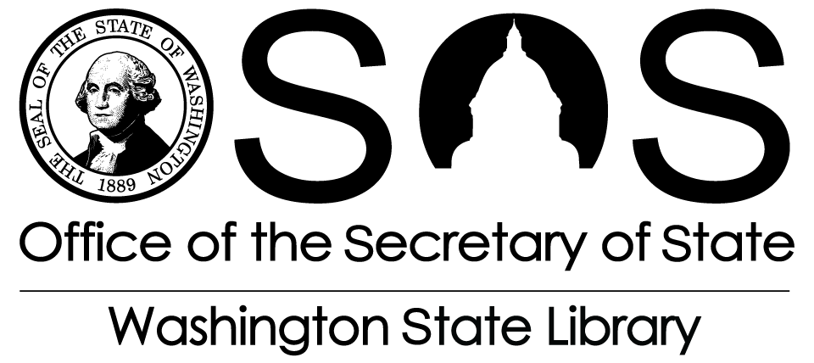  2014 Broadband Grant Guidelines | GRANTS
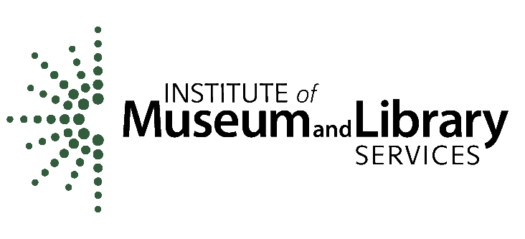
This grant cycle is supported with Library Services and Technology Act funding provided by the federal Institute of Museum and Library Services.

CONTENTS
- Introduction
- Library Eligibility
- Project Eligibility
- Funding Available
- Timeframe
- Application Process
- Requirements
- Assurances
- Contact Information

1. Introduction
The purpose of this grant cycle is to provide grant funds allowing public and tribal libraries to upgrade and/or add network hardware and software to take advantage of significantly enhanced broadband connectivity. Preference will be given to those libraries participating in a Round One or Two of the ARRA* Broadband (NTIA BTOP**) grants awarded to the Northwest Open Access Network (NoaNet); and to libraries with service populations of less than 10,000.
2. Library Eligibility
Public libraries and Native American tribal libraries (as defined in Section 213 of the Library Services and Technology Act) within Washington State are eligible to submit applications for this grant cycle. The Library Services and Technology Act (LSTA) eligibility guidelines may be reviewed at: http://www.sos.wa.gov/library/libraries/grants/eligibility.aspx.

*ARRA is the American Recovery and Reinvestment Act of 2009.
**NTIA is the National Telecommunications and Information Administration, and BTOP is the Broadband Technology Opportunity Program.
In addition, the following limits shall apply to project applications:
- Applicant must be undertaking significant Internet connectivity upgrades to speeds of 10Mbps (megabits per second) or greater.
- Applicant must be compliant with the Children’s Internet Protection Act (CIPA).
- Enhanced connectivity must be or projected to be in place and utilized by August 1, 2014.

The following is a list of selection criteria:
- Preference will be given to those libraries participating in and utilizing that connectivity made possible through the American Recovery and Reinvestment Act/Broadband Technology Opportunity Program (ARRA/BTOP) Round One/Two grants awarded to NoaNet.
- Service population – preference given to libraries of less than 10,000.
- Projected/actual increase in bandwidth requiring enhancement to network infrastructure.
- Rationale for network enhancements and ability to successfully complete project.
- Benefit to patrons of this project (e.g. expanded access to information in a variety of formats; providing informational, educational and recreational programs and services; etc.).

3. Project Eligibility
Grant funds are to be used to allow libraries to upgrade and/or add network hardware and software from the circuit point of demarcation inward:
- Network hardware and software may include, but not be limited to routers; switches; cabling and wiring; content filtering, and; firewalls.
- Grant funds MAY NOT cover network servers, staff/public access computers, peripherals, or software that is not covered in grant agreements (contracts).
- Funding for this grant opportunity will be limited to not more than $10,000 per library system.

For more guidance view the “Allowable Costs” section of WSL’s Grant Management Information page: http://www.sos.wa.gov/library/libraries/grants/grantees.aspx.
4. Funding Available
Overall funding to support this grant cycle is $100,000. This grant cycle has a limit of $10,000 per application. It is anticipated that ten (10) or more applicants may receive awards. Awards will be made contingent upon receipt of federal funds and distribution of those funds by the Washington State Library (WSL), a division of the Office of the Secretary of State.
5. Timeframe
The following timeline has been developed for the purpose of providing information about this grant cycle and to assist applicants in developing appropriate projects and applications.

Tentative Dates
- Monday, February 3, 2014 —Tentative date for grant cycle opening
- Friday, March 14, 2014 — Application deadline; applications postmarked or delivered after this date will not be accepted
- March 17 – April 25, 2014 — Application review by committee
- April 28 – May 2, 2014 —The Secretary of State and the State Librarian review and approve committee’s recommendations
- Monday, May 5, 2014 — Anticipated date for grant award announcement; contract development begins
- June 6, 2014 — Anticipated date that all contracts are fully executed (signed by both parties) and that project implementation can begin
- Project period — From date contract is signed by both parties through Friday, September 12, 2014 (end of contract)
- Friday, September 12, 2014 — Date contract ends; all project activity must end, including the delivery of materials and services purchased
- Friday, October 10,2014 — Final Narrative Report and final reimbursement claim due
6. Application Process
- Review grant cycle materials at http://www.sos.wa.gov/library/libraries/grants/grants.aspx. The grant cycle opens on Monday, February 3, 2014.

An announcement of the grant cycle is sent via mail or e-mail to various email lists including WSL Updates and the Washington Library Association (WLA), and to those who have requested to be notified of this grant cycle.

Application guidelines, forms, and other materials may be obtained by visiting the WSL Web site and printing appropriate Web pages or downloading the Word files. Materials may also be obtained by contacting the LSTA Grants Manager as noted at the end of these guidelines.

- Review the criteria contained within the application to determine eligibility to apply.

- Respond to the criteria, checking either yes or no for each item.

- Complete the application form; reply to all questions. Secure all required signatures. Include CIPA certification form.

- General questions regarding the application process may be answered by contacting the Broadband Project Manager or the Grants Program staff by e-mail or phone. Staffing limitations preclude review and comment on draft applications.

- Submit applications to the Washington State Library postmarked by Friday, March 14, 2014 or hand delivered by 4 p.m. on Friday, March 14, 2014. Faxed applications are NOT acceptable for this funding request.

An application consists of three components:
- A single-sided, signed original of the official 2014 Broadband application, clearly identified as the original
- A paper copy; and
- An electronic copy in Word or rich text format (on USB drive or CD); or sent as an email attachment to allyson.ruppenthal@sos.wa.gov.
Send one complete application per envelope. If you are applying for multiple grants, send each separately. This will ensure that there is no confusion during the review process and your applications will each receive due consideration.

Submit application materials to:

By Mail By Hand or Delivered
LSTA Grants Program LSTA Grants Program
Washington State Library Washington State Library
PO Box 42460 6880 Capitol Blvd SE
Olympia, Washington 98504-2460 Tumwater, WA 98501-5513

- A fully completed and signed application received in the mail or hand delivered will be accepted for the purposes of review and ranking.

- A review committee selected by WSL will review the applications for eligibility. If eligible requests exceed available funding, awards will be based on application scoring. The review committee will forward recommendations to the State Librarian and the Secretary of State for final consideration and approval. WSL may contact the applicant for clarification of information.

- After award of funding, a letter of notification will be sent to all applicants. Contracts will then be established with those receiving awards. Reimbursable project costs may not be incurred until contracts are fully signed (executed) by both the Office of the Secretary of State (Washington State Library) and the award recipient. Costs incurred prior to contract execution are not reimbursable.

7. Requirements
- Libraries are sometimes granted funds contingent upon fulfilling one or more requirements prior to project implementation. Libraries must meet those contingencies prior to contract execution.
- Libraries must expend local money first and then claim reimbursement. Funds will not be distributed in advance of activities and purchases taking place. Funds will only be distributed on a reimbursement basis. Funds requested for the proposed project must not take the place of previously budgeted local funding.

- Applicant/sub-grantee overhead expenses and administrative costs are not eligible for LSTA reimbursement. They may be used as match for the proposed project.

- The purchase of all equipment costing over $5,000, made in whole or in part with grant funding, is not allowable.

- Items included under “Other Funding” and used as match or in-kind contributions may be monitored during project implementation. Documentation of these expenses will be required.

- Applicants must commit to compliance with grant administration requirements. A final report will be submitted to WSL providing a complete summary of the project and of all grant activities by October 10, 2014. Reimbursement claims will be made on forms provided by WSL by October 10, 2014. Documentation of expenses will be required.

- Children’s Internet Protection Act (CIPA): All applicants must complete a CIPA certification form (available online at http://sos.wa.gov/library/libraries/libdev/technology/cipa.aspx#grant) with the grant application.

- The Washington State Library and the Institute of Museum and Library Services (IMLS) must be acknowledged as providing LSTA funding to support the project in all project-related public events, press releases, printed materials, and Web sites.

- All projects and activities must be completed and funds expended by Friday, September 12, 2014. Applicants proposing projects that will use LSTA grant funding beyond September 12, 2014 will not be considered for this grant cycle.

8. Assurances
The Washington State Library and the Sub-Grantee agree that all activity pursuant to a Grant Agreement will be in accordance with all applicable, current, or future federal, state, and local laws, rules, and regulations. Specifically, this includes laws, rules, and regulations such as:
- 45 Code of Federal Regulations (CFR) Part 1168, New Restrictions on Lobbying;
- 45 Code of Federal Regulations (CFR) Part 1180.44, Nondiscrimination;
- 45 Code of Federal Regulations (CFR) Part 1183, Uniform Administrative Requirements for Grants and Cooperative Agreements;
- 45 Code of Federal Regulations (CFR) Part 1185, Government Wide Debarment and Suspension (Nonprocurement) and Government Wide Requirements for Drug-Free Workplace (Grants);
- 2 Code of Federal Regulations (CFR) Part 175, Award Term for Trafficking in Persons;
- Office of Management and Budget (OMB) Circular A-21 Revised, Cost Principles for Educational Institutions (now codified as 2 CFR Part 220);
- Office of Management and Budget (OMB) Circular A-87 Revised, Cost Principles for State, Local and Indian Tribal Governments (now codified as 2 CFR Part 225);
- Office of Management and Budget (OMB) Circular A-122, Cost Principles for Non-Profit Organizations (now codified as 2 CFR Part 230); and
- Office of Management and Budget (OMB) Circular A-133 Revised, Audits of States, Local Governments, and Non-Profit Organizations.

Code of Federal Regulations (CFR)
The CFRs can be inspected by accessing the following URL for the Electronic Code of Federal Regulations: http://ecfr.gpoaccess.gov/cgi/t/text/text-idx?c=ecfr&tpl=%2Findex.tpl.
- On this page is a drop-down box under “Browse”. To inspect 45 CFR Part 1183, select Title 45 – Public Welfare from the drop-down box and click on the “Go” button. A search list is returned that includes specific parts, chapters, and volumes of 45 CFR.
- If you are interested in inspecting 45 CFR Part 1183 or another part of this Title listed below, scroll to and click on the part labeled 1100-1199, National Foundation on the Arts and the Humanities.
- You will find one item titled 1183 under Subchapter E – Institute of Museum and Library Services. Click on this link for access to all sections of PART 1183―UNIFORM ADMINISTRATIVE REQUIREMENTS FOR GRANTS AND COOPERATIVE AGREEMENTS TO STATE AND LOCAL GOVERNMENTS. This item contains the full text of this title in html format. Use this same technique to find other parts of this title.
- If you are interested in just a part of this overall title and you know the name for the specific section, such as Copyrights, scroll to the title for that section.

The Code of Federal Regulations 45 CFR Part 1185 provides that an individual, corporation, unit of government or other entity that is debarred or suspended shall be excluded from Federal financial or non-financial assistance and benefits under Federal programs and activities.

Office of Management and Budget (OMB) Circulars
The following OMB Circulars can be inspected by accessing the following URL: http://www.whitehouse.gov/omb/grants/index.html Click on “Circulars.” The specific circular of interest can then be selected.

OMB Circular A-21 establishes principles for determining costs applicable to grants, contracts, and other agreements with educational institutions.

OMB Circular A-87 establishes principles and standards for determining costs for Federal awards carried out through grants, cost reimbursement contracts, and other agreements with State and local governments and federally-recognized Indian tribal governments (governmental units).

OMB Circular A-122 establishes principles for determining costs of grants, contracts and other agreements with non-profit organizations.

OMB Circular A-133 is issued pursuant to the Single Audit Act of 1984, P.L. 98-502, and the Single Audit Act Amendments of 1996, P.L. 104-156. It sets forth standards for obtaining consistency and uniformity among federal agencies for the audit of states, local governments, and non-profit organizations expending federal awards.

Other Requirements:
If the Sub-Grantee includes a construction component as part of the overall project even if this component is not funded by federal funds, the following shall also apply and includes laws, rules, and regulations that are the provisions of 45 CFR 1183.36(i); including but not limited to:

- Section 306 of the Clean Air Act (42 U.S.C. 1857(h)), and section 508 of the Clean Water Act (33 U.S.C. part 15). Note: Applies to contracts, subcontracts, and sub-grants of amounts in excess of $100,000.

- Mandatory standards and policies relating to energy efficiency which are contained in the State Energy Conservation Plan issued in compliance with the Energy Policy and Conservation Act (Pub. L. 94-163).

- Compliance with the Copeland “Anti-Kickback” Act (18 U.S.C. 874) as supplemented in Department of Labor regulations (29 CFR part 3). Note: Applies to all contracts, grants, and sub-grants for construction or repair.

- Compliance with the Davis-Bacon Act (40 U.S.C. 276a to a-7) as supplemented by Department of Labor regulations (29 CFR part 5). Note: Applies to construction contracts in excess of $2,000 awarded grantees and sub-grantees when required by Federal Grant Program legislation.

- Compliance with sections 103 and 107 of the Contract Work Hours and Safety Standards Act (40 U.S.C. 327-330) as supplemented by Department of Labor regulations (29 CFR part 5). Note: Applies to construction contracts awarded grantees and sub-grantees in excess of $2,000, and in excess of $2,500 for other contracts which involve employment of mechanics or laborers.

9. Contact Information
- Web site for grant information: http://www.sos.wa.gov/library/libraries/grants/grants.aspx
- Gary Bortel, Project Manager/IT Services Manager, 360.570.5578, gary.bortel@sos.wa.gov

Allyson Ruppenthal, LSTA Grants Manager, 360.704.5246, allyson.ruppenthal@sos.wa.gov

